|  |  |  |
| --- | --- | --- |
|  | **BOSTON**  **UNIVERSITY** | **METROPOLITAN COLLEGE**  **DEPARTMENT OF ADMINISTRATIVE SCIENCES** |

**AD 616: Enterprise Risk Analytics**

**Assignment 5**

**What to submit?**

Please submit (i) a word file explaining in detail your answers to each question (you can use screenshots of the R to explain your answers) AND (ii) R file with a picture of the decision tree. For each question, make sure you develop the model and present the simulation results – R file should be self-explanatory. **The assessment of your work will include both the accuracy and the clarity of your word file and the R File.**

1. Video Tech is considering marketing one of two new video games for the coming Holiday season1: Battle Pacific or Space Pirates. Battle Pacific is a unique game and appears to have no competition. Estimated profits (in thousands of dollars) under high, medium, and low demand are as follows:

|  |  |  |  |
| --- | --- | --- | --- |
|  | **Demand** | | |
| **Battle Pacific** | **High** | **Medium** | **Low** |
| Profit | $1000 | $700 | $300 |
| Probability | 0.2 | 0.5 | 0.3 |

Video Tech is optimistic about its Space Pirates game. However, the concern is that profitability will be affected by a competitor’s introduction of a video game viewed as similar to Space Pirates. Estimated profits (in thousands of dollars) with and without competition are as follows:

|  |  |  |  |
| --- | --- | --- | --- |
| **Space Pirates** | **Demand** | | |
| **With Competition** | **High** | **Medium** | **Low** |
| Profit | $800 | $400 | $200 |
| Probability | 0.3 | 0.4 | 0.3 |

|  |  |  |  |
| --- | --- | --- | --- |
| **Space Pirates** | **Demand** | | |
| **Without Competition** | **High** | **Medium** | **Low** |
| Profit | $1600 | $800 | $400 |
| Probability | 0.5 | 0.3 | 0.2 |

For planning purposes, Video Tech believes there is a 0.6 probability that its competitor will produce a new game similar to Space Pirates. Given this probability of competition, the director of planning recommends marketing the Battle Pacific video game. Using expected value, what is your recommended decision and what is the expected profit?

Answer: From the decision tree below, we can find the best decision is to publish the game Space Pirates. Cause it has a higher expect value which is $724,000 .

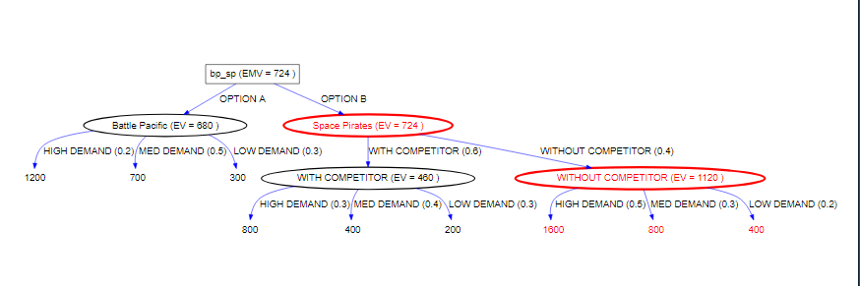

1. Reconsider the problem in Question 1. Suppose that the profits (in thousands of dollars) are uncertain.

For Battle Pacific:

* When demand is high, the profit is normally distributed with mean 1000 and standard deviation 100.
* When demand is medium, the profit is normally distributed with mean 700 and standard deviation 70.
* When demand is low, the profit is normally distributed with mean 300 and standard deviation 30.

For Space Pirates with competition:

* When demand is high, the profit is normally distributed with mean 800 and standard deviation 80.
* When demand is medium, the profit is normally distributed with mean 400 and standard deviation 40.
* When demand is low, the profit is normally distributed with mean 200 and standard deviation 20.

For Space Pirates without competition:

* When demand is high, the profit is normally distributed with mean 1600 and standard deviation 160.
* When demand is medium, the profit is normally distributed with mean 800 and standard deviation 80.
* When demand is low, the profit is normally distributed with mean 400 and standard deviation 40.

Incorporate this information to your decision tree. What is the probability that the expected profit will be less than $724.000?

Answer: No, it will be same. Because even if we change the profit to a normal distribution. Its expect value is still same.

For example, For Battle Pacific: When demand is high, the profit is normally distributed with mean 1000 and standard deviation 100. The expect value is still 1000. It’s same with the expect value in question 1. So the total expect value won’t change.

1. A company must decide whether to manufacture a component part in its plant or purchase the component part from a supplier. The resulting profit is dependent upon the demand for the product. The following payoff table shows the projected profit (in thousands of dollars):

|  |  |  |  |
| --- | --- | --- | --- |
|  | **State of Nature** | | |
| **Decision Alternative** | **Low Demand, s1** | **Medium Demand,s2** | **High Demand,s3** |
| Manufacture,d1 | -20 | 40 | 100 |
| Purchase, d2 | 10 | 45 | 70 |

The state-of-nature probabilities are P(s1) = 0.35, P(s2) = 0.35, and P(s3) = 0.30.

1. Use a decision tree to recommend a decision.

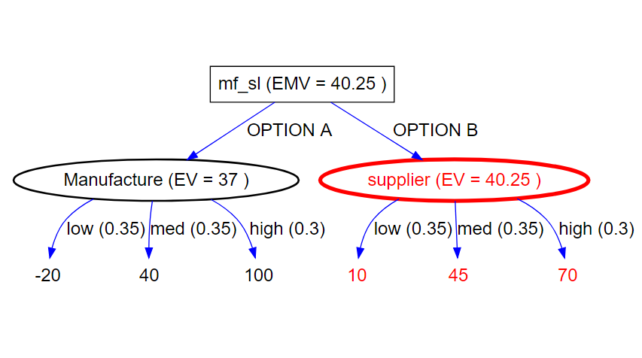

So, The company should find a supplier.

1. A test market study of the potential demand for the product is expected to report either a favorable (F) or unfavorable (U) condition. The relevant conditional probabilities are as follows:

P(F|s1) = 0.10 P(U|s1) =0.90

P(F|s2) = 0.40 P(U|s2) = 0.60

P(F|s3) = 0.60 P(U|s3) = 0.40

What is the probability that the market research report will be unfavorable?

P(U)=P(S1) *P(U|s1)+ P(s2)* P(U|s2)+ P(s3)* P(U|s3)

=0.35*0.9+0.35*0.6+0.3*0.4 =0.645

1. What is the company’s optimal decision strategy?

P(S1|F)= P(S1) *P(F|s1)/ P(F)= P(S1) *P(F|s1)/(1-P(U))=0.35*0.1/0.355=0.035/0.355

P(S2|F)= P(S2) *P(F|s2)/ P(F)= P(S2) *P(F|s2)/(1-P(U))=0.35*0.4/0.355=0.14/0.355

P(S3|F)= P(S3) *P(F|s3)/ P(F)= P(S3) *P(F|s3)/(1-P(U))=0.3*0.6/0.355=0.18/0.355

EV(d1|F)= P(S1|F)*(-20)+ P(S2|F)*40+ P(S3|F)*100= 64.50704

EV(d2|F)= P(S1|F)*10+ P(S2|F)*45+ P(S3|F)*70= 54.22535

When the marketing is favorable the company should make decision 1(Manufacture).

P(S1|U)=P(S1)* P(U|s1)/P(U)= 0.35*0.9/0.645=0.315/0.645

P(S2|U)=P(S2)* P(U|s2)/P(U)= 0.35*0.6/0.645=0.21/0.645

P(S3|U)=P(S3)* P(U|s3)/P(U)= 0.3*0.4/0.645=0.12/0.645

EV(d1|U)= P(S1|U)*(-20)+ P(S2|U)*40+ P(S3|U)*100= 21.86047

EV(d2|U)= P(S1|U)*10+ P(S2|U)*45+ P(S3|U)*70= 32.55814

When the marketing is unfavorable the company should make decision 2(Purchase).

1. What is the expected value of the market research information?

EV=P(F)* EV(d1|F)+P(U)* EV(d2|U)=0.355*64.50704+0.645*32.55814=43.9